# Redefining Cybersecurity's First Line of Defense

Human Firewall, Vulnerabilities, Social Engineering, Awareness, Culture

July 31, 2023

[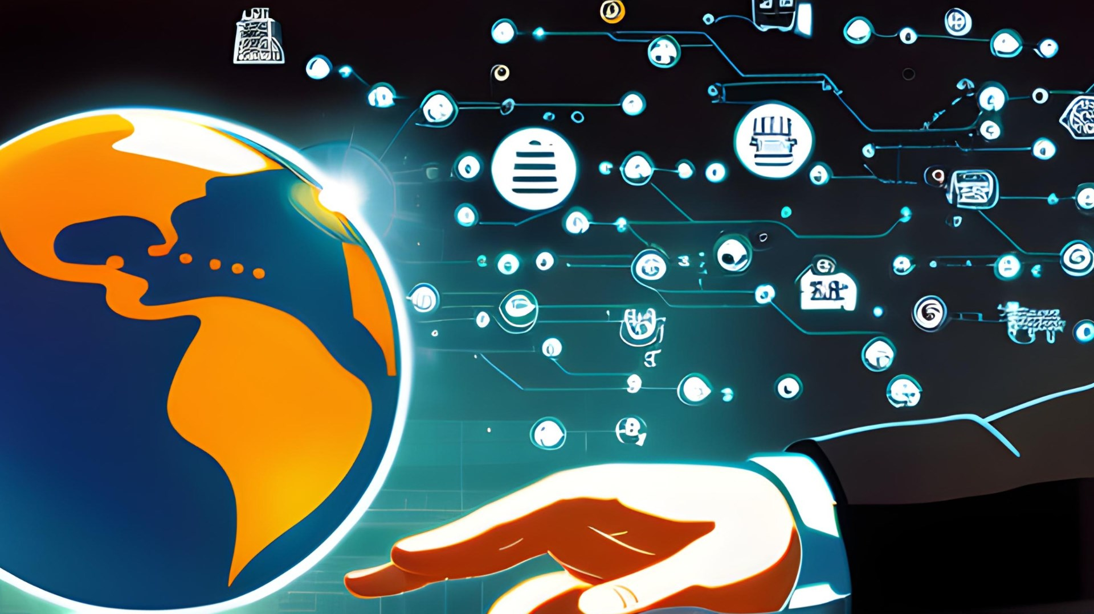](https://user-images.githubusercontent.com/131223318/259496219-aac87ad7-e7c0-41e2-b3ae-9a2fa5ff5a17.jpg)

In the ever-evolving landscape of cybersecurity, the concept of "humans as the weakest link" has become a prevailing adage. But as we delve deeper into the intricacies of cyber threats and the psychology behind human behavior, we may find ourselves questioning whether this adage holds true. Are humans genuinely the weakest link in security, or could there be more to the story? Join us on this captivating journey as we unravel the enigma of cybersecurity and explore the multifaceted role humans play in safeguarding our digital world.

## The Human Factor

It is undeniable that human actions can indeed create vulnerabilities in cybersecurity. Phishing attacks, for instance, rely on exploiting human curiosity, trust, and lack of awareness. Social engineering techniques, whether through email or phone calls, manipulate individuals into divulging sensitive information or falling prey to malicious links. These attacks highlight the profound impact human vulnerabilities can have on organizational security.

However, pinning the blame solely on these actions overlooks our inherent resilience and adaptability. We as humans, possess the unique ability to learn and grow from experiences, making us capable of adapting to evolving threats. With proper education, awareness, and training, individuals can become a formidable line of defense against cyber threats.

## The First Defensive Line

Rather than considering humans as the weakest link, I see ourselves as the first line of defense, the "human firewall" that guards against cyber intrusions. Empowering employees with cybersecurity knowledge not only enhances their ability to detect potential threats but also instills a sense of responsibility towards protecting organizational assets.

Promoting a culture of cybersecurity awareness within organizations can foster an environment where employees proactively report suspicious activities and collaborate in thwarting attacks. Furthermore, human intuition and critical thinking abilities are invaluable assets in identifying anomalies that automated security systems might miss.

## The Psychological Aspect

To truly grasp the complexities of human involvement in cybersecurity, we must delve into the psychological aspects of human behavior. Cognitive biases, such as the urgency effect or the authority bias, can make individuals susceptible to manipulation and exploitation. Understanding these biases can help design more effective cybersecurity training and awareness programs.

Additionally, factors like stress, fatigue, and multitasking can impair decision-making and increase the likelihood of human errors. Organizations must address these challenges by creating a supportive work environment that encourages work-life balance and stress management.

## Moving Forward

Instead of solely relying on our human capabilities to defend against cyber threats, we can leverage technology to complementand enhance our efforts. Artificial Intelligence (AI) and Machine Learning (ML) algorithms can analyze vast amounts of data and patterns, detecting potential threats at an unprecedented scale. By automating routine tasks and augmenting human decision-making, technology can reduce human errors and alleviate the burden on cybersecurity professionals.

By arming ourselves with cybersecurity knowledge and fostering a culture of awareness, we can actively contribute to the protection of organizational assets. Our human intuition and critical thinking abilities enable us to detect anomalies that automated systems might overlook.

Moreover, as we acknowledge our cognitive biases and understand the psychological aspects of human behavior, we can tailor more effective cybersecurity training and awareness programs to fortify our defenses further.

So, are humans genuinely the weakest link in security? I am convinced that, united, we can surpass any perceived weaknesses and become a powerful alliance that stands strong against the ever-evolving cyber threats. Let us remember that our potential to protect the digital realm is vast, and together, we hold the key to a safer and more secure cyber landscape.

# Resources:

* [[Click Here]](https://lumu.io/blog/7-habits-effective-cybersecurity-operators/) *Lumu Technologies: 7 Habits of Highly Effective Cybersecurity Operators (2021)*
* [[Click Here]](https://www.schneier.com/wp-content/uploads/2015/08/paper-psychology-of-security.pdf) *The Psychology of Security by Bruce Schneier (2008)*
* [[Click Here]](https://www.proofpoint.com/us/blog/email-and-cloud-threats/2022-human-factor-report-explores-year-headline-making-attacks) *Proofpoin's Human Factor Report (2022)*
* [[Click Here]](https://security.it.iastate.edu/threats/awareness/sites) *Iowa State University: IT Security*
* [[Click Here]](https://www.cisa.gov/) *Cybersecurity and Infrastructure Security Agency (CISA)*
* [[Click Here]](https://www.ncsc.gov.uk/collection/board-toolkit/developing-a-positive-cyber-security-culture#:~:text=Security%20culture%20refers%20to%20the,and%20leadership%20of%20your%20organisation.) *The National Cyber Security Centre (NCSC)*
* [[Click Here]](https://business.bt.com/why-choose-bt/insights/cyber-security/human-firewall-against-cyberattacks/) *BT Business: What is a human firewall and how can it help my business? (2022)*
* [[Click Here]](https://cybeready.com/ultimate-guide-to-human-firewalls) *CyberReady: Ultimate Guide to Human Firewalls (2022)*
* [[Click Here]](https://www.electric.ai/blog/human-firewall) *Electric: What is a Haman Firewall? (2022)*
* [[Click Here]](https://mitsloan.mit.edu/ideas-made-to-matter/how-to-build-a-culture-cybersecurity) *MIT Management Sloan School (MITSloan) [2022]*